**Difference between HTTP/2 and HTTP/1.1**

HTTP stands for hypertext transfer protocol & it is used in client-server communication. By using HTTP user sends the request to the server & the server sends the response to the user. There are several stages of development of HTTP but we will focus mainly on HTTP/1.1 which was created in 1997 & the new one is HTTP/2 which was created in 2015.

**HTTP/1.1:**

* For better understanding, let’s assume the situation when you make a request to the server for the **guvi**.html page & server responds to you as a resource **guvi**.html page. before sending the request and the response there is a TCP connection established between client & server. Again you make a request to the server for image img.jpg & the server gives a response as an image img.jpg. the connection was not lost here after the first request because we add a keep-alive header which is the part of the request so there is an open connection between the server & client. there is a persistent connection which means several requests & responses are merged in a single connection. These are the drawbacks that lead to the creation of HTTP/2: The first problem is HTTP/1.1 transfer all the requests & responses in the plain text message form. The second one is head of line blocking in which TCP connection is blocked all other requests until the response does not receive. all the information related to the header file is repeated in every request.

## **Key Features of HTTP/1.1:**

* It was no longer required for each connection to be terminated immediately after every request was served with a response; instead, with the keep-alive header, it was possible to have persistent connections. It allowed multiple requests/responses per TCP connection.
* The Upgrade header was used to indicate a preference from the client that made it possible to switch to a more preferred protocol if found appropriate by the server.
* HTTP/1.1 provided support for chunk transfers that allowed streaming of content dynamically as chunks and for additional headers to be sent after the message body. This enhancement was particularly useful in cases where values of a field remained unknown until the content had been produced. For example, when the content had to be digitally signed, it was not possible to do so before the entire content gets generated.
* Other features that reinforced its stability were introduced such as:
  + pipelining (the second request is sent before the response to the first is adequately served)
  + content negotiation (an exchange between client and server to determine the media type, it also provides the provision to serve different versions of a resource at the same URI)
  + cache control (used to specify caching policies in both requests and responses)

| **HTTP/1.1** |  |  | **HTTP/2** |
| --- | --- | --- | --- |
| It works on the textual format. |  |  | It works on the binary protocol. |
| There is head of line blocking that blocks all the requests behind it until it doesn’t get its all resources. |  |  | It allows multiplexing so one TCP connection is required for multiple requests. |
| It uses requests resource Inlining for use getting multiple pages |  |  | It uses PUSH frame by server that collects all multiple pages |
| It compresses data by itself. |  |  | It uses HPACK for data compression. |

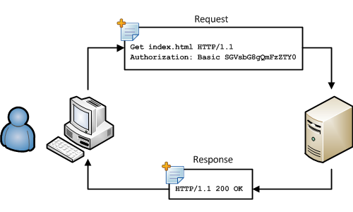

**HTTP/2:**

* HTTP/2 was developed over the SPDY protocol. HTTP/2 works on the binary framing layer instead of textual that converts all the messages in binary format. it works on fully multiplexed that is one TCP connection is used for multiple requests. HTTP/2 uses HPACK which is used to split data from header. it compresses the header. The server sends all the other files like CSS & JS without the request of the client using the PUSH frame.
* Introduces the concept of multiplexing that interleaves the requests and responses without head-of-line blocking and does so over a single TCP connection.

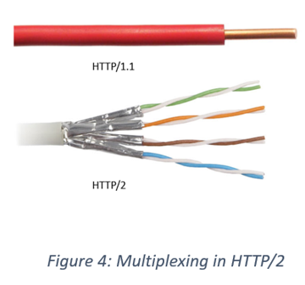

|  |  |  |  |
| --- | --- | --- | --- |
| Differentiator |  | HTTP/1.1 | HTTP/2 |
| Year |  | 1997 | 2015 |
| Key Features |  | It supports connection reuse i.e. for every TCP connection there could be multiple requests and responses, and pipelining where the client can request several resources from the server at once. However, pipelining was hard to implement due to issues such as head-of-line blocking and was not a feasible solution. | Uses multiplexing, where over a single TCP connection resources to be delivered are interleaved and arrive at the client almost at the same time. It is done using streams which can be prioritized, can have dependencies and individual flow control. It also provides a feature called server push that allows the server to send data that the client will need but has not yet requested. |
| Status Code |  | Introduces a warning header field to carry additional information about the status of a message. Can define 24 status codes, error reporting is quicker and more efficient. | Underlying semantics of HTTP such as headers, status codes remains the same. |
| Authentication Mechanism |  | It is relatively secure since it uses digest authentication, NTLM authentication. | Security concerns from previous versions will continue to be seen in HTTP/2. However, it is better equipped to deal with them due to new TLS features like connection error of type Inadequate_Security. |
| Caching |  | Expands on the caching support by using additional headers like cache-control, conditional headers like If-Match and by using entity tags. | HTTP/2 does not change much in terms of caching. With the server push feature if the client finds the resources are already present in the cache, it can cancel the pushed stream. |